**Molecular Insights into Host Use and Pathogen Acquisition by an Insect Leafhopper Vector in Potato Crop Fields**

Camille Wagstaff1, Jillian J. Foutz1, 2, W. Rodney Cooper2, Derek Pouchnik3, Heather Headrick2, Riley M. Anderson1, David W. Crowder1

1 Washington State University, Department of Entomology, Pullman, Washington 99164, USA

2 USDA ARS Temperate Tree Fruit and Vegetable Research Unit, Wapato, Washington 98951, USA

3 Washington State University, Laboratory for Biotechnology and Bioanalysis, Genomics Laboratory, Pullman, Washington 99164, USA

Corresponding author details:

Camille Wagstaff

Washington State University, Department of Entomology, Pullman, WA, 99164, USA

Camille.wagstaff@wsu.edu

**Abstract**

Insect vectors are notoriously difficult to manage due to their ability to utilize a wide range of host plants across seasons. Improving vector management requires novel approaches that assess host use across space and time to predict pathogen transmission dynamics. Molecular gut content analysis of vector insects has been instrumental in identifying host use but is often limited by its inability to directly link hosts to pathogen transmission. Here, we integrate gut content analysis with pathogen incidence to determine the role of various host plants in *Neoaliturus tenellus* (previously *Circulifer tenellus* Baker) (Beet leafhopper: *Hemiptera: Cicadellidae*)movement and pathogen spread. We tested 236 leafhoppers collected from 15 sites over three years to assess host utilization and pathogen acquisition. Our results confirm that *N. tenellus* acquire pathogens from *Sisymbrium* spp. and *Brassica* spp. (wild mustards) in the spring, while *Salsola/Kali* spp. (Russian thistle) and *Bassia* spp. (kochia) serve as primary *N. tenellus* hosts throughout the summer. A new discovery, we detected gut content from trees, including *Tilia* spp. (linden), *Prunus* spp./*Pyrus* spp. /*Citrus* spp (fruit), and *Tsuga* spp./*Pinus* spp, (pine) suggesting previously unknown host interactions. These findings refine our understanding of vector ecology and highlight the importance of host use patterns in predicting pathogen transmission, ultimately improving risk assessments and integrated pest management strategies.

**Keywords:** gut content analysis, beet curly top virus, purple top disease, phytoplasma, landscape ecology, pest population dynamics, vector monitoring

**Introduction**

Many insect pests that are vectors of pathogens are generalists that feed on diverse hosts across landscapes and seasons (Gutiérrez-López et al. 2020; Weintraub and Beanland 2006). Generalist vectors are notoriously difficult to manage due in part to their ability to move between different crop types and non-crop weedy hosts (Gutiérrez Illan et al. 2020; Heck 2018; Nault 1997). Areawide management is challenging to coordinate, and large patches of weedy hosts are often unmanaged nearby commercial production areas, providing sources of vector populations at variable points during crop seasons (Bennet 1971). Pathogens that are transmitted by vectors also have variable ability to attack different host species, and these infectivity traits may not always align with vector host preferences (Thapa and Ghersi 2023). A comprehensive understanding of host use by vectors and pathogens is key for predicting vector and pathogen dynamics and forecasting disease outbreaks while also aiding in developing mitigation strategies.

Effective vector management requires innovative approaches to assess host use over space and time to better predict pathogen transmission dynamics (Rafter and Walter 2020). One emerging technique to assess insect host use is molecular gut content analysis, which identifies ingested plant DNA within insect digestive systems to reconstruct trophic interactions (Cooper et al. 2019; Cooper at al. 2022; Pitt et al. 2024). When molecular gut content analysis is combined with structured surveys of insects across broad regions, the technique can be used to infer patterns of insect movement across broad landscapes within and across seasons (Cooper et al. 2019; Strausbaugh et al. 2024). While gut content analysis cannot directly establish a link between vector feeding events and pathogen acquisition, integrating gut content analysis with pathogen incidence data could clarify the relationships between host use and pathogen spread.

The ecology of many insect vectors, such as the beet leafhopper (*Neoaliturus tenellus* Baker; Hemiptera: Cicadellidae), is often largely based on natural history surveys or structured surveys of agricultural systems (Brewster and Allen 1997; Damos 2015; Wohleb et al. 2021). However, for many vectors, the plant hosts that serve as pathogen reservoirs, and thereby pose the greatest risk to crops, are largely inferred rather than directly known (Horton et al. 2018). For example, it may often be assumed that most hosts used by a vector will also be hosts for pathogens transmitted by that vector, or that the hosts will be a predictable subset of the plant phylogeny the vector uses (Perilla-Henao and Casteel 2016). Molecular tools are an effective way to bridge this knowledge gap, as the same insects can be tested for the pathogens they carry as well as their prior host use (Cooper et al. 2019; Cooper at al. 2022; Pitt et al. 2024).

Here, we leveraged molecular gut content analysis to trace landscape-scale movements of *N. tenellus* in a major potato production region of the United States, the Columbia River Basin region of Washington State. As the sole vector of *Beet curly top virus* (BCTV), *Candidatus* Phytoplasma trifolii (CPt), and *Spiroplasma citri* (*S. citri*) in the Columbia River Basin, *N. tenellus* facilitates pathogen spread across cropping areas throughout the season (Cooper et al. 2023). Previous monitoring suggests that wild Brassicaceae species serve as overwintering reservoirs, while Amaranthaceae species support leafhopper populations during the growing season (Horton et al. 2018). However, it is still relatively unknown which non-crop and crop hosts are most associated with particular pathogens. Over three years, we analyzed 236 adult *N. tenellus* collected from 15 sites across the Columbia Basin to determine seasonal host use and pathogen incidence. This knowledge can enhance targeted control measures and mitigate crop losses associated with leafhopper-borne pathogens and associated crop diseases.

**Materials & Methods:**

***Study system***

Leafhopper-transmitted pathogens threaten many crops in the western United States, including potatoes and seed crops such as sugar beet, carrot, spinach, hemp, sunflower, and coriander (Hudson et al. 2010; Munyaneza et al. 2006a; Nachappa et al. 2020; Rondon and Murphy 2016; Soto and Gilbertson 2003). Gut adaptations of *N. tenellus* allow pathogens to traverse the stomach lining and colonize within their salivary glands, facilitating highly efficient transmission (Knowlton 1929; Suzuki et al. 2006; Frantz et al. 2023). Further, *N. tenellus* does not exhibit strong host specificity, often feeding on hosts that cannot fully support development, which enhances its ability to spread pathogens across diverse hosts (Thomas and Boll 1977). In turn, the persistence and annual resurgence of pathogens are closely linked to the life cycle and migratory behavior of *N. tenellus*. Overwintering females lay eggs in spring, and nymphs acquire pathogens from weedy host plants before dispersing into agricultural fields (Lee et al. 2022; Meyerdirk and Hessein 1985; Meyerdirk and Moratorio 1987). Early-season populations tend to establish on weeds in the Brassicaceae family, which serve as primary hosts (Hudson et al. 2010). As temperatures rise in mid-April and these weed hosts dry out, *N. tenellus* disperse into summer crops (Horton et al 2018; Munyaneza et al. 2006b). This seasonal movement plays a role in the epidemiology of BCTV and CPt, yet the full extent of host use and pathogen transmission across seasons remains poorly understood. To better characterize seasonal host use of *N. tenellus* and its role in pathogen transmission, we conducted molecular gut content analysis across three growing seasons.

***Site Selection and Sampling***

Sampling was conducted at sites across the Columbia River Basin during the 2019 and 2020 growing seasons and in spring of 2021 (Fig. 1). Most sites were included in the Washington State University’s potato pest monitoring network, a standardized sampling network on commercial farms; additional sites were at University research farms. In 2019 and 2020, sampling focused on irrigated potato fields and adjacent weedy areas, while in 2021 collections occurred near potato fields before planting (Fig. 1). Our approach aims to identify key plant species that may serve as hosts at different times of the year, and plant tissue samples from collection sites were tested for the presence of pathogens to assess potential sources of infection (Foutz et al. 2025). Linking vector molecular gut content analysis with pathogen detection, may resolve host-pathogen interactions and improve predictive models for disease outbreaks. Sampling occurred every other week in 2019 and 2020 and weekly in 2021. Insects were collected using a reversible leaf blower, suctioned into organdy bags, and transferred to resealable plastic bags (26cc Gas Handheld Blower Vacuum, Homelite Corporation, Charlotte, NC). All potential weedy host stands within 100 m of potato fields were sampled for one minute per plant stand. Additionally, five leaves per sampled stand of weeds or potatoes were collected for pathogen testing. Live insects and plant samples were transported on ice and immediately frozen at -40 °C upon arrival at the laboratory. Although *N. tenellus* are difficult to identify due to their similarity to other leafhopper non-vector species commonly found, adults *N. tenellus* measure 3 to 4 mm in length, with a pale green to tan coloration and a tapered, bullet body shape (Colorado State University). Identification and sexing were performed under a stereo microscope using distinct morphological traits, and specimens were stored in a -40 °C freezer.

Of the 1,765 adult *N. tenellus* collected across the Columbia Basin from 2019 to 2021 in this manner, 236 *N. tenellus* from potato fields were haphazardly selected for gut content analysis to assess seasonal host use and pathogen transmission dynamics. Initially, we surveyed infection status based on the host plant species from which leafhoppers were collected. In 2019, a total of 66 *N. tenellu*s individuals were selected from kochia, potato, russian thistle, pigweed, and (how many) other mustards and assayed for infection status. . This sub-sample revealed minimal infection incidence, limiting our ability to detect viable host reservoirs. Consequently, in 2020 we reversed our approach by first establishing infection status. Gut content analysis was performed on 24 BCTV-infected leafhoppers, 25 *C*Pt-infected leafhoppers, 23 leafhoppers co-infected with both BCTV and CPt, and 25 healthy or non-infected leafhoppers. Previous research indicates that leafhoppers may obtain these pathogens from weeds used in overwintering and that the greatest threat to crop infection may be in spring as leafhoppers transition from overwintering hosts to new crop growth (Utah State University). To explore the validity of the spring migration hypothesis we focused our sampling in 2021, to include 73 individual beet leafhoppers collected across the spring and early summer season.

***DNA Extraction***

Individual adult *N. tenellus* were surface sterilized by sequentially immersing them individually in 70% ethanol for 5 seconds, sterile deionized water for 5 seconds, followed by a 60-second treatment in 1% bleach, and two final 5-second rinses in sterile deionized water. Specimens were then air-dried on Kimtech Science™ Kimwipes™ placed within a sterile petri dish. Total DNA was extracted using the DNeasy Blood and Tissue Kit (Qiagen, Hilden, Germany) following the manufacturer’s protocol. All extraction procedures were carried out in a UV-sterilized biosafety cabinet to prevent contamination. To assess DNA quality and concentration, a subset of the extracted samples was evaluated using a Nanodrop spectrophotometer (ThermoFisher Scientific, Waltham, MA). Negative controls lacking DNA templates were included throughout the extraction and analysis process to verify that no contamination was present in the reagents. All extracted DNA samples were stored at -20 °C until further molecular procedures were carried out.

***Pathogen Identification***

Testing for the presence of *Ca*. P. trifolii (CPt) in insects was done using real-time PCR on a Lightcycler 480 (Roche, Basel, Switzerland) with these conditions: a 5 min hold at 95 °C, 20 cycles of 95 °C for 10 sec, 65 °C for 10 sec, and 72 °C for 10 sec, then 20 cycles of 95 °C for 10 sec, 55 °C for 10 sec, and 72 °C for 10 sec, a melting curve to assess primer specificity, and a cooling cycle. Each 20 μL reaction contained 10 μL of SYBR™ Green PCR Master Mix (ThermoFisher Scientific, Waltham MA), 8.2 μL of nuclease-free water, 0.4 μL each of *Ca*. P. trifolii primers “z-R16R2-wfB_F” (AAA TAT TTC TCG GGG TTT GTA CAC ACC GCC CGT CA) and “BLTVA-int-wfB_R” (AAT TAT CTC TGA TGA TTT TAG TAT ATA TAG TCC) at 20 μM concentration, and 1 μL of extracted *N. tenellus* DNA (Cooper et al. 2023, Swisher Grimm et al. 2023).

Testing for the presence of *Beet curly top virus* (BCTV)in samples was by conventional PCR on a BioRad thermocycler with these conditions: 1 min at 95 °C, 20 cycles of 95 °C for 15 s, 65 °C for 30 s (touchdown, Δ−0.5 °C), and 72 °C for 20 s, then 20 cycles of 95 °C for 15 s, 55 °C for 30 s, and 72 °C for 20 s, then 1 min at 72 °C before an infinite hold at 4 °C until samples were removed. Each 20 μL reaction contained 10 μL of Amplitaq Gold 360 Master Mix (ThermoFisher Scientific, Waltham, MA), 8.6 μL of nuclease-free water, 0.2 μL each of primers “BCTV2-F” (GTG GAT CAA TTT CCA GAC AAT TAT C) and “BCTV2-R” (CCC ATA AGA GCC ATA TCA AAC TTC) at 20 μM concentration, and 1 μL of extracted *N. tenellus* DNA (Strausbaugh et al. 2008, Swisher Grimm et al. 2023). Infection was confirmed by visualizing the approximately 520-bp PCR products under UV light on a 1% agarose gel stained with GelRed (Biotium, Fremont, CA).

Samples from 2019 and 2020 were also tested for the presence of the bacterium *Spiroplasma citri*, another plant pathogen transmitted exclusively by *N. tenellus*. Testing for the presence of *S. citri* was done using conventional PCR with conditions identical for *Beet curly top virus* identification listed above. Each 20 μL reaction contained 10 μL of Amplitaq Gold 360 Master Mix, 8.6 μL of nuclease-free water, 0.2 μL each of primers “S.citri-1” (GGT CTG CTG CTT TAA TTT CTA C) and “S.citri-2” (TGC AGC ACC TGC AAC TGT AG) at 20 μM concentration, and 1 μL of extracted *N. tenellus* DNA (Cooper et al. 2023, Swisher Grimm et al. 2023). *S. citri* infection was determined by visualizing the approximately 350-bp PCR products under UV light on a 1% agarose gel with GelRed staining. Only 8% (8/97) of tested samples showed infection of *S. citri*. Due to low infection levels, *S. citri* was left out of further analysis. For a collaborative project, 51 of these 2020 *N. tenellus* were sequenced using Restriction site-associated DNA sequencing (RAD-seq) (unpublished Gina Angelella).

For molecular pathogen detection in this study, we used Real-time PCR, and not quantitative PCR. This approach was chosen as presence/absence data was sufficient to address the study’s research objectives. DNA concentrations were not standardized across samples; therefore, Cq values are not reported, as they do not accurately reflect pathogen titers in insect tissues.

***Molecular Gut Content Analysis***

The dietary profiles of *N. tenellus* were investigated using high-throughput, single-molecule real-time (SMRT) sequencing on the PacBio sequencing platform. Plant-derived DNA was amplified from individual insect gut extractions using primers targeting two common plant barcoding loci: the chloroplast trnF region and the nuclear internal transcribed spacer 2 (ITS2). PCR amplification was conducted separately for each locus using universal primers: trnF (B49873-e: GGTTCAAGTCCCTCTATCCC; A50272-f: ATTTGAACTGGTGACACGAG; Taberlet et al., 1991) and ITS2 (ITS2F: ATGCGATACTTGGTGTGAAT; ITS3R: GACGCTTCTCCAGACTACAAT; Chen et al., 2010). To enable numerous samples to be sequenced in the same pooled set, each sample was assigned a unique combination of asymmetric barcoded forward and reverse primers (Pacific Biosciences, 2014) as described in Cooper et al. 2019 and 2022. Reactions were performed in 50 µL volumes, using 40uL Invitrogen Amplitaq Gold 360 PCR Master Mix at 62.5% (Invitrogen, Carlsbad, CA), 250 nM of each primer (or 5 µmol/L of forward and reverse primers), and 5 µL of DNA template.

Thermocycler conditions for PCR of ITS2 included an initial denaturation at 94 °C for 5 minutes, followed by 35 cycles of 94 °C for 30 seconds, 56 °C for 30 seconds, and 72 °C for 45 seconds, with a final extension of 5 minutes at 72 °C. For trnF, cycling conditions were slightly adjusted: an initial denaturation at 94 °C for 10 minutes, 40 cycles of 94 °C for 30 seconds, 58 °C (or 52 °C for some optimized reactions) for 30 seconds, and 72 °C for 45 seconds, followed by a 5-minute final extension at 72 °C. Amplicon sizes approximately 500 bp were confirmed through visualization on electrophoresis 1% agarose gels stained with either ethidium bromide or SYBR® Safe (Thermo Fisher Scientific).

The remaining PCR product volumes for pooling were adjusted based on band intensity, and PCR products were cleaned using QIAquick® PCR Purification Kits (Qiagen, Hilden, Germany) prior to pooling. Each pooled sample set included no-template controls (NTCs) containing water and positive controls consisting of one psyllid species collected directly from known host plants, each with their own unique barcode set to monitor contamination and PCR efficiency. The pooled library was concentrated using AMPure XP beads (Beckman Coulter), end-repaired, ligated to SMRTbell adapters with the Express Template Prep Kit v2.0, and quantified prior to sequencing on 1M v3 SMRT cells using the Sequel Binding Kit 3.0. The run was conducted for 10 hours at the Washington State University Laboratory for Biotechnology and Bioanalysis Genomics Lab. Raw sequence data were processed using SMRT Link v6.0 to generate high-quality circular consensus sequences (CCS). Demultiplexed reads were filtered to retain only sequences between 400 and 700 bp and with a minimum quality threshold (Phred ≥ 40, inferred accuracy ≥ 0.9999). Sequence data were analyzed using Geneious Prime® (v2023.1.2). Operational taxonomic units (OTUs) were generated via de novo assembly using custom parameters (95% minimum overlap identity, 1% max gaps per read, and 5% max mismatches). OTUs represented by five or fewer reads were excluded to minimize the inclusion of artifacts or potential contamination. BLASTn searches against the NCBI GenBank database were used to assign taxonomic identities, with matches reported to the genus level for greater reliability (Altschul et al. 1990). A plant taxon was considered present in a sample if at least six reads matched a given OTU, a threshold consistent with previous metabarcoding studies (Cooper et al., 2022). Given that prior research (Avanesyan et al., 2021) has shown plant DNA signal intensity may not correlate with feeding intensity or time since ingestion, dietary results were interpreted qualitatively as presence/absence data.

***Analysis***

Data was evaluated to explore seasonal trends in *N. tenellus* infection status and variation in host plants found in guts across the Columbia River Basin. Formal inferential statistics were not the primary focus due to the seasonal nature of sampling and the variability in gut content results. The dataset includes both presence and absence records of *N. tenellus* associated pathogens and the genera found within *N. tenellus* guts. We observed seasonal patterns in the landscape-level movement of *N. tenellus* and the pathogens they transmit. We found gut contents to be consistent between infected and non-infected *N. tenellus.*

To explore broader patterns, we applied random forest analysis, principal component analysis (PCA), and non-metric multidimensional scaling (NMDS) across variables including site location, seasonality, year, and infection status. These multivariate analyses did not identify clear trends, indicating that our sampling provides a representative overview of the Columbia Basin. Additionally, a generalized logistic regression was performed to evaluate whether pathogen infection influenced the diversity of plant genera detected in beet leafhopper gut contents. The number of plant genera was compared between infected and uninfected *N. tenellus* adults using R v3.5.2 (R Development Core Team, 2018).

**Results:**

The analysis confirmed a feeding preference for Amaranthaceae and Brassicaceae weed species, particularly *Salsola/Kali* spp. (Russian thistle), *Bassia* spp. (kochia), *Sisymbrium* spp. (tumble mustard), and *Descurainia* spp. (flixweed). Among these, *Salsola* spp. emerged as the primary host, followed by *Brassica* spp. (wild mustards) and *Amaranthus* spp. (kochia) (Figure 1). Notably, while over half of the *N. tenellus* containing *Salsola* spp. tested positive for pathogens, *Salsola* spp. itself exhibited low infection rates, highlighting complexities in pathogen transmission dynamics (unpublished, Foutz 2025). Additional plant families detected in gut contents included *Solanaceae* spp. (nightshades), *Asteraceae* spp. (prickly lettuce, fleabane, horseweed), and *Amaranthus* spp. (pigweed). Economic crops such as *Solanum tuberosum* (potato), *Solanum lycopersicum* (tomato), *Raphanus sativus* (radish), *Brassica carinata* (rapeseed), and *Cannabis sativa* (hemp) were also detected.

In the spring, wild mustards and flixweed serve as primary pathogen hosts, while kochia becomes a dominant pathogen reservoir in the summer and remains infected through the fall (Figure 2). Notably, as wild mustards bolt and trees begin budding in the spring, *N. tenellus* appears to migrate upward, potentially facilitating early-season pathogen spread. A novel discovery in this study was the detection of tree species in *N. tenellus* gut contents, suggesting previously unrecognized host interactions. We identified feeding on *Tilia* spp. (linden), *Prunus* spp., *Pyrus* spp., and *Citrus* spp. (fruit trees), as well as *Tsuga* spp. and *Pinus* spp. (pine trees) (Figure 1).

Pathogen analysis revealed that regardless of *N. tenellus* infection status, the same diversity of plants were found in guts. The even distribution of infections across host plants prevented identification of a specific pathogen-associated host. However, logistic models demonstrated a negative relationship between BCTV infection and gut richness, indicating that infection rates decline as *N. tenellus* consumes a greater diversity of plant species. In contrast, CPt infection varied independently of gut richness (Figure 3).

* Add the percentage of *N. tenellus* w/ RT, Kochia, Mustards, Trees, and other common genera found in gut (broken up by year and add total from all 3 years)
* Add GLM/GLR = higher BCTV=less plants (although could reflect seasonality instead of infection status)
* Add seasonal trends = mustards in spring

**Discussion:**

**DISCUSSION OUTLINE**

***Paragraph 1 –*** What did this study tell us overall, what were the implications, impacts, etc. You have parts of this when you talk about the “big picture” nature of your study

***Paragraph 2 –*** Our results reveal that mustards are the primary spring host. Trees are also a major host. What do these things mean about life cycle, management, etc

***Paragraph 3 –*** Other results are less prominent but confirm seasonal patterns

***Paragraph 4 –*** Our results reveal that certain plants that are common hosts may not actually be good for pathogen. What does this tell us?

***Paragraph 5 –*** Why do you see the negative relationship between host diversity for BCTV not BLTVA. What might this tell us about mode of transmission and host suitability

***Paragraph 6 –*** Caveats and limitations

***Paragraph 7 –*** Back to big picture, next steps, etc

The significance of this research lies in its novel integration of gut content analysis with pathogen testing, offering a more comprehensive understanding of *N. tenellus* host use and its role in disease transmission. By identifying the plants that *N. tenellus* feeds on and correlating this data with pathogen presence, we uncover critical ecological interactions that drive vector-mediated disease outbreaks. This combined methodology enhances our ability to predict disease risk, optimize management strategies, and improve agricultural disease mitigation efforts.

Our findings revealed extensive feeding on non-reproductive host species, including economically significant crops, and provided unexpected insights into *N. tenellus* behavior.

…

indicating that *N. tenellus* may contribute to pathogen spread within agricultural systems. This underscores the need for further research to clarify the role of these crops in vector-mediated disease transmission.

Our research also revealed significant seasonal trends in *N. tenellus* movement, influenced by temperature changes and plant phenology. These findings raise questions about the ecological role of trees in *N. tenellus* seasonal movement and their potential influence on pathogen transmission.

These findings likely reflect differences in pathogen life cycles—BCTV can only replicate within host plants, whereas CPt proliferates inside *N. tenellus.* Previous research has suggested that viruliferous insects exhibit altered behavior, potentially reducing movement and increasing feeding on infected plants to acquire a higher virus load (Han et al. 2024). Our findings support this hypothesis and provide new insights into how vector behavior influences disease spread.

These findings may also be influenced by seasonal variation. Our sampling efforts were not evenly distributed across years, with 2019 primarily focused on fall collections and 2021 emphasizing spring collections. The observed trend of BCTV-infected *N. tenellus* having fewer plant species in their gut contents could be linked to the timing of their collection (Figure 3). In the spring, *N. tenellus* nymphs hatch and develop on infected mustards, remaining relatively stationary until rising summer temperatures kill their preferred weed hosts, forcing migration into irrigated crops. By fall, *N. tenellus* begin seeking shelter and identifying suitable overwintering hosts. This search for an overwintering host may drive more selective feeding behavior, potentially leading to a greater diversity of plants detected in gut content analyses.

A potential limitation of this study is the specificity of DNA barcoding primers, which may bias results toward certain genera. To address this, we used two primer types—ITS for broad taxonomic identification and trnF for targeting specific weed species. Additionally, we validated results at the genus level to account for potential sequencing errors and DNA degradation. These methodological refinements enhance the accuracy of our findings and strengthen our interpretations of *N. tenellus* feeding ecology and pathogen transmission.

The economic impact of this research is substantial. Growers currently rely on intensive insecticide applications, costing approximately $400 per acre annually, to mitigate leafhopper-borne diseases (Galinato 2020). By refining our understanding of *N. tenellus* movement and feeding behavior, we can enhance predictive models and decision-support systems, such as those used for potato pest management, potentially reducing unnecessary pesticide applications and saving growers millions of dollars annually. Our findings are incorporated into Washington State University’s Decision Aid System (DAS), which provides precision pest management recommendations and has already saved potato farmers $9 million annually. Expanding this system to specialty crops and hemp could generate similar economic benefits while promoting sustainable pest management practices and reducing pesticide use.

**Figure Legends**

**Map of Sites.** Map of study sites using GPS coordinates for where *N. tenellus* were collected from each year.

**Figure 1. *Neoaliturus tenellus* Gut Content Analysis.** Bar chart displaying the count of plant genera detected in individual *N. tenellus* gut contents, categorized into three groups: crops, non-crop or weeds, and trees. The x-axis represents the number of leafhoppers in which each plant type was detected, while the y-axis lists the plant genera identified. The legend indicates infection status, with co-infection referring to the presence of both *Candidatus* Phytoplasma trifolii (CPt) and Beet Curly Top Virus (BCTV).

**Figure 2. Seasonality of *Neoaliturus tenellus* Gut Content Analysis.** Ridge plot illustrating seasonal trends in the plant genera detected in *N. tenellus* gut contents, grouped into crops, non-crop weeds, and trees. The x-axis represents the collection date of leafhopper samples, while the y-axis lists the plant genera identified. The density ridges indicate the periods when specific plant species were most frequently detected in gut contents, providing insight into seasonal shifts in feeding behavior.

**Figure 3. Predicted Probability of Infection.** Scatterplot displaying the relationship between gut content diversity and pathogen infection in *N. tenellus*. The x-axis represents the number of plant genera detected per individual leafhopper, while the y-axis shows the percentage of leafhoppers infected with either BCTV or CPt. Panel A illustrates the probability of Beet curly top virus infection, whereas Panel B depicts infection rates for *Candidatus* Phytoplasma trifolii. The analysis examines how feeding abundance influences infection likelihood, providing insights into vector-pathogen dynamics.

**Map of Sites**

**Figure 1**

**Figure 2**

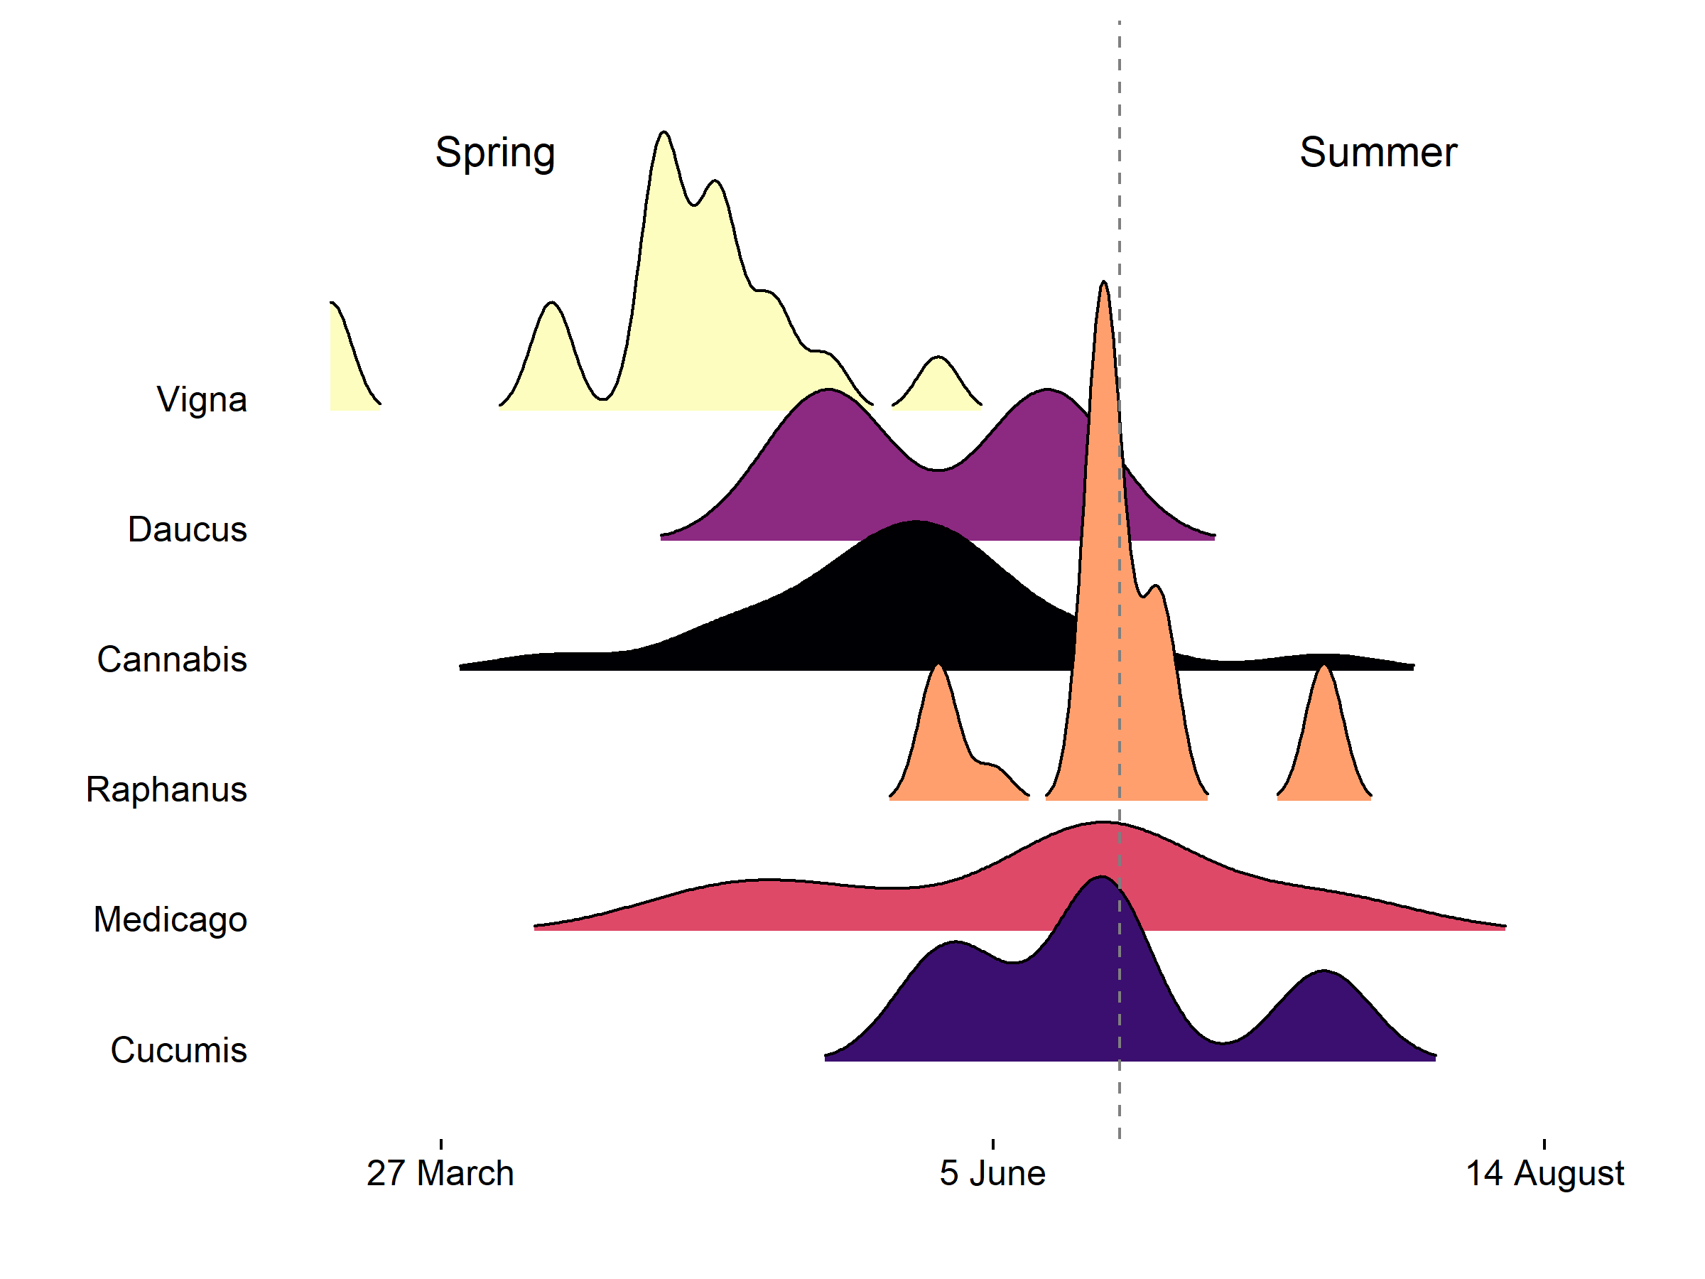

Crop Non-Crop Tree

**Figure 3**

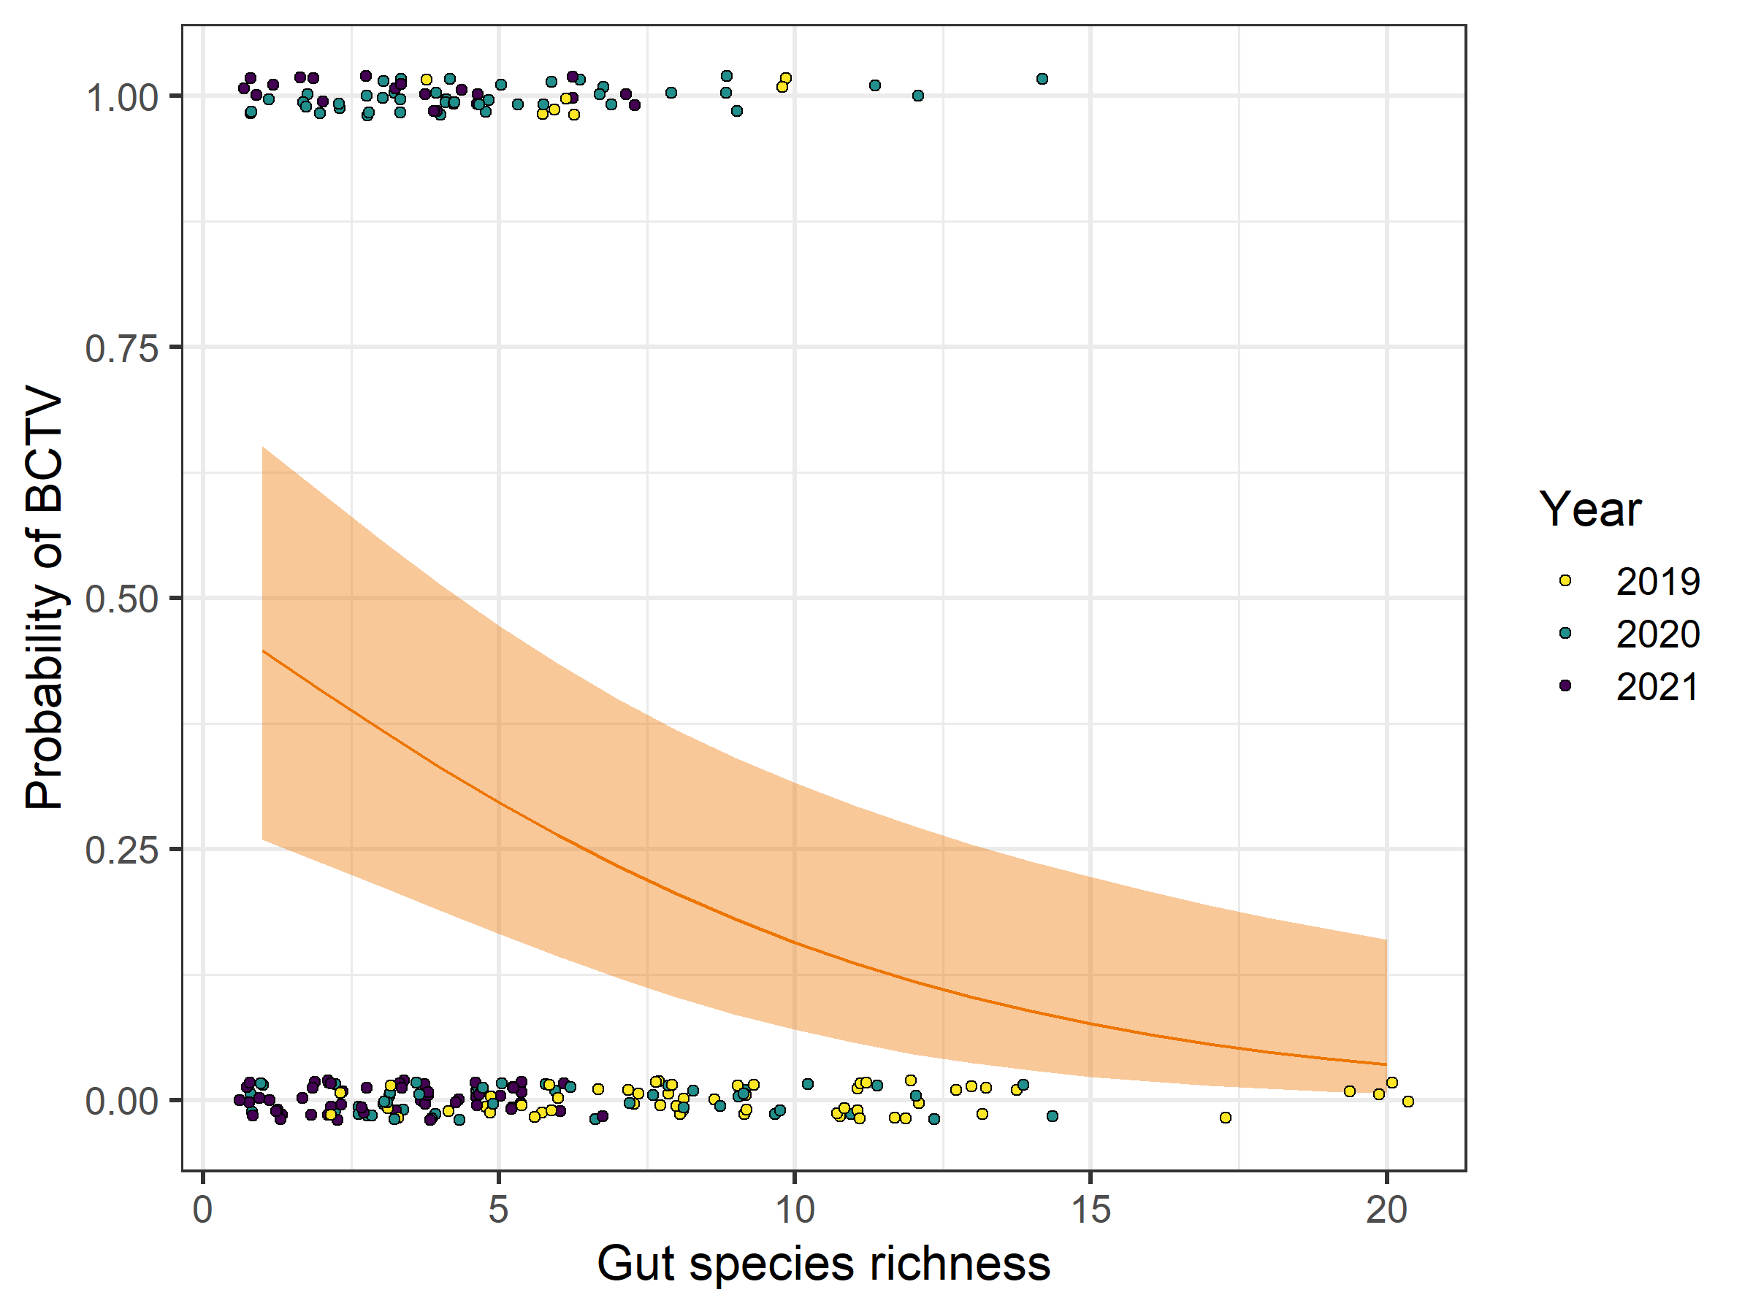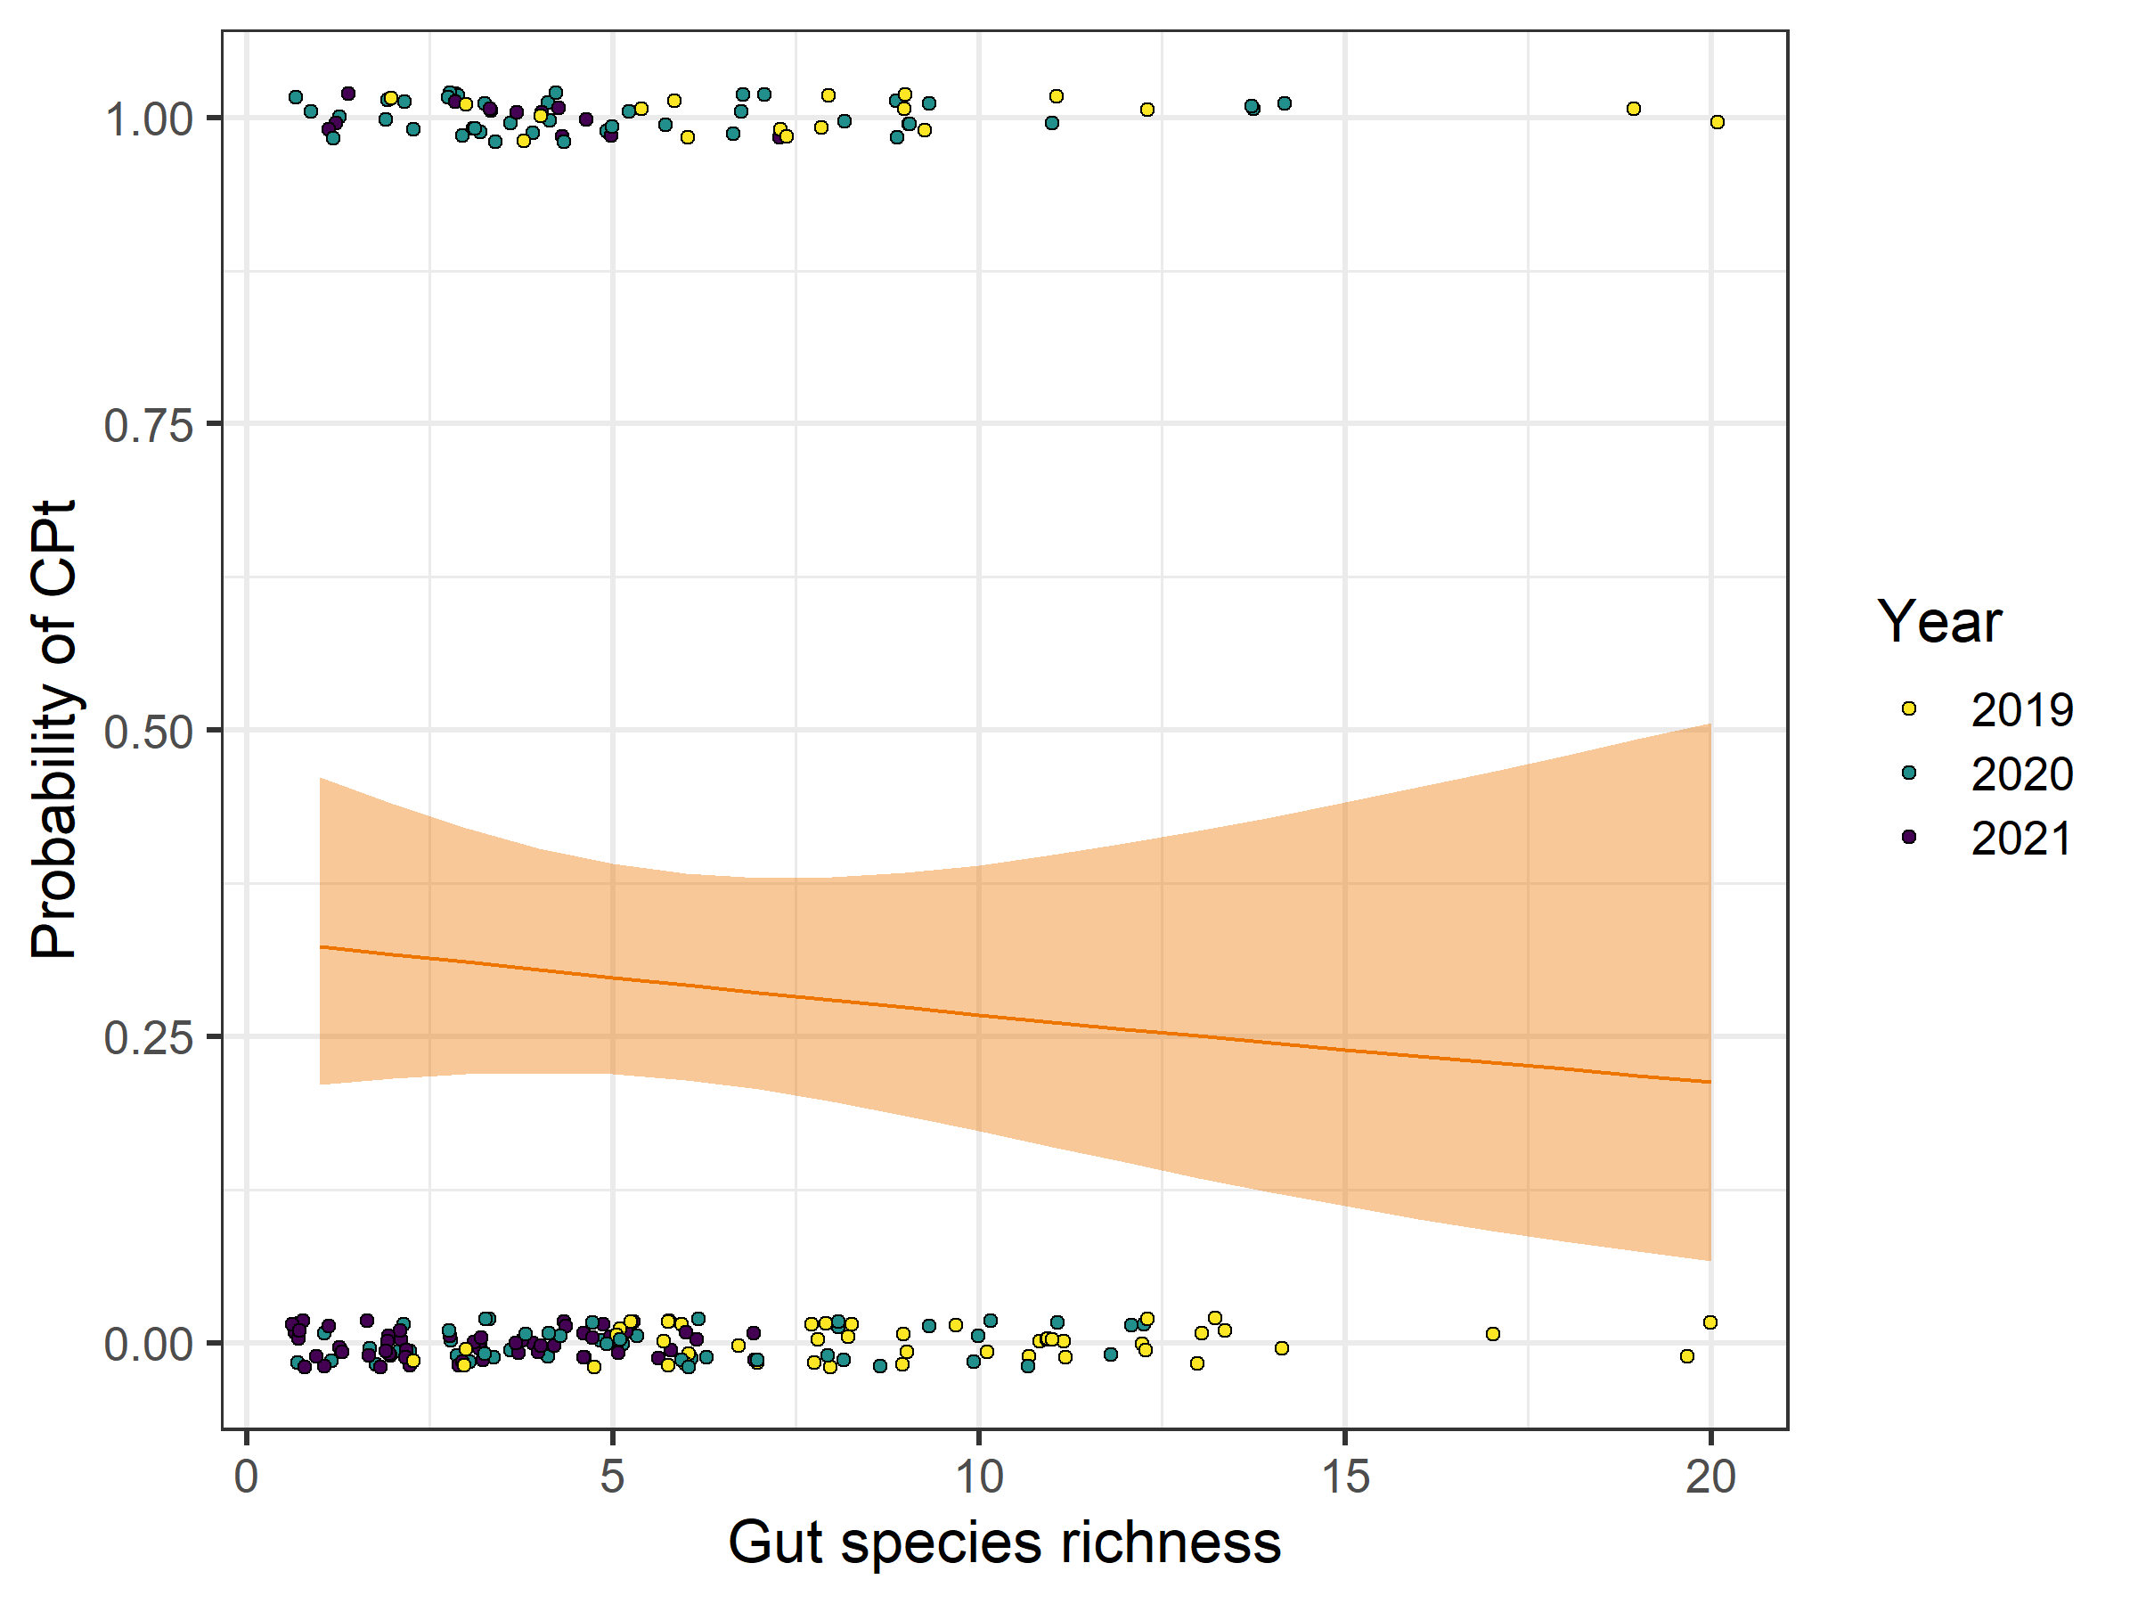

**3.A**: BCTV **3.B**: CP

**References**

Altschul SF, Gish W, Miller W, Myers EW, Lipman DJ. Basic local alignment search tool. J Mol

Biol. 1990 Oct 5;215(3):403-10. doi: 10.1016/S0022-2836(05)80360-2. PMID: 2231712.

Avanesyan, A., Illahi, N. and Lamp, W.O. (2021) Detecting ingested host plant DNA in potato

leafhopper (Hemiptera: Cicadellidae): potential use of molecular markers for gut content analysis. *Journal of Economic Entomology*, 114, 472–475.

Bennett, C. W. 1971. The Curly Top Disease of Sugarbeet and Other Plants, Monograph No. 7.

American Phytopathological Society, St. Paul, MN, U.S.A.

Brewster CC, Allen JC. 1997. Spatiotemporal model for studying insect dynamics in large-scale cropping systems. *Environ. Entomol.* 26:473–482.

Colorado State University. (n.d.). Beet leafhopper (*Neoalitarsus tenellus*) and beet curly top virus. Available <https://agsci.colostate.edu/agbio/ipm-pests/beet-leafhopper-beet-curly-top-virus/>

Cooper WR, Horton DR, Wildung MR, Jensen AS, Thinakaran J, Rendon D, Nottingham LB, Beers EH, Wohleb CH, Hall DG, Stelinski LL (2019) Host and non-host 'whistle stops' for psyllids: molecular gut content analysis by high-throughput sequencing reveals landscape-level movements of Psylloidea (Hemiptera). *Environmental Entomology* 48:603-613.

Cooper WR, Marshall AT, Foutz JJ, Wildung MR, Northfield TB, Crowder DW, Leach H, Leskey TC, Halbert SE, Snyder JB (2022) Directed sequencing of plant specific DNA identifies the dietary history of four species of of Auchenorrhyncha (Hemiptera), *Annals of the Entomological Society of America* 115:275-284.

Cooper WR, Walker WB, Angelella GM, Swisher Grimm KD, Foutz JJ, Harper SJ, Nottingham LB, Northfield TB, Wohleb CH, Straushbaugh CA (2023) Bacterial endosymbionts identified from leafhopper (Hemiptera: Cicadellidae) vectors of phytoplasmas. *Environmental Entomology* 52:243-253.

Damos P. 2015. Modular structure of web-based decision support systems for integrated pest management. A review. *Agron. Sustain. Dev.* 35:1347–1372.

Frantz R, Nischwitz C, Compton T, Gordillo LF (2023) Modeling the spread of curly top disease in tomatoes. *Letters in Biomathematics* 10:53-61.

Galinato SP (2020) 2019 cost estimates of producing fresh and processing potatoes in Washington. Washington State University Extension, 67E.

Gutiérrez Illán J, Bloom EH, Wohleb CH, Wenninger EJ, Rondon SI, Jensen AS, Snyder WE, Crowder DW. 2020. Landscape structure and climate drive population dynamics of an insect vector within intensely managed agroecosystems. *Ecol. Appl.* 30:1–13.

Gutiérrez-López, Rafael & Bourret, Vincent & Loiseau, Claire. (2020). Is Host Selection by Mosquitoes Driving Vector Specificity of Parasites? A Review on the Avian Malaria Model. Frontiers in Ecology and Evolution. 8. 569230. 10.3389/fevo.2020.569230.

Han J, Cui M, Withycombe J, Schmidtbauer M, Chiginsky J, Neher OT, Strausbaugh CA, Majumdar R, Nalam VJ, Nachappa P (2024) Beet curly top virus affects vector biology: the first transcriptome analysis of the beet leafhopper. *Journal of Genetic Virology* 105:7.

Harveson RM (2015) Beet curly top: America’s first serious disease of sugar beets. *APS Features,* <https://www.apsnet.org/edcenter/apsnetfeatures/Pages/CurlyTop.aspx>

Heck M. Insect Transmission of Plant Pathogens: a Systems Biology Perspective. mSystems. 2018 Mar 20;3(2):e00168-17. doi: 10.1128/mSystems.00168-17. PMID: 29629417; PMCID: PMC5881024.

Horton, D. R., W. R. Cooper, K. S. Grimm, D. Crowder, Z. D. Fu, T. Waters, C. Wohleb, K. Frost, and A. Jensen. 2018. The Beet Leafhopper Odyssey in North America: A Brief Overview. Potato Prog. 18: 1–1

Hudson A, Richman DB, Escobar I, Creamer R (2010) Comparison of the feeding behavior and genetics of beet leafhopper, *Circulifer tenellus*, populations from California and New Mexico. *Southwestern Entomologist* 35:241-250.

Knowlton, G. F. 1929. Bulletin No. 212-Studies on the Morphology of the Beet Leafhopper.Lai et al 2009

Lee H, Wintermantel WM, Trumble JT, Fowles TM, Nansen C. Modeling and validation of oviposition by a polyphagous insect pest as a function of temperature and host plant species. PLoS One. 2022 Sep 2;17(9):e0274003. doi: 10.1371/journal.pone.0274003. PMID: 36054184; PMCID: PMC9439214.

Meyerdirk DE, Moratorio MS. 1987. *Circulifer tenellus* (Baker), the beet leafhopper (Homoptera: Cicadellidae): laboratory studies on fecundity and longevity. *The Canadian Entomologist*. 1987;119(5):443-447. doi:10.4039/Ent119443-5

Meyerdirk, D.E., & Hessein, N.A. (1985). Population Dynamics of the Beet Leafhopper, Circulifer tenellus (Baker), and Associated Empoasca spp. (Homoptera: Cicadellidae) and Their Egg Parasitoids on Sugar Beets in Southern California. *Journal of Economic Entomology, 78*, 346-353.

Munyaneza, J. E., Crosslin, J. M., & Upton, J. E. 2006a. Beet leafhopper (Hemiptera: Cicadellidae) transmits the Columbia Basin potato purple top phytoplasma to potatoes, beets, and weeds. *Journal of Economic Entomology*, *99*(2), 268-272.

Munyaneza, J.E., Crosslin, J., Jensen, A.S., Hamm, P.B., Schreiber, M.E. 2006b. Beet leafhopper and potato purple top disease: 2005 season recap and new research directions. 45th Annual Proceedings Washington State Potato Conference. 2006: 107-118

Nachappa P, Fulladolsa AC, Stenglein M (2020) Wild wild west: emerging viruses and viroids of hemp. *Outlooks on Pest Management* 31:175-179.

Nault LR, Ammar ED. 1989. Leafhopper and planthopper transmission of plant viruses. *Ann. Rev. Entomol.* 34:503–529.

Perilla-Henao LM, Casteel CL. Vector-Borne Bacterial Plant Pathogens: Interactions with Hemipteran Insects and Plants. Front Plant Sci. 2016 Aug 9;7:1163. doi: 10.3389/fpls.2016.01163. PMID: 27555855; PMCID: PMC4977473.

Pitt WJ, Cooper WR, Pouchnik D, Headrick H, Nachappa P. High-throughput molecular gut content analysis of aphids identifies plants relevant for potato virus Y epidemiology. Insect Sci. 2024 Oct;31(5):1489-1502. doi: 10.1111/1744-7917.13327. Epub 2024 Feb 6. PMID: 38319817.

R Development Core Team. 2018. “R version 3.5.2. R: A Language and Environment for Statistical Computing.” R Foundation for Statistical Computing, Vienna, Austria.

Rafter MA, and Walter GH. 2020. Generalizing about generalists? A perspective on the role of pattern and process in investigating herbivorous insects that use multiple host species. *Arthropod Plant Interact*. 14:1–20.

Rondon SI, and A.F. Murphy (2016) Monitoring and controlling the beet leafhopper Circulifer tenellus in the Columbia Basin. *American journal of potato research*, *93*, 80-85.

Soto MJ, Gilbertson RL (2003) Distribution and rate of movement of the curtovirus beet mild curly top virus (Geminiviridae) in the beet leafhopper. *Phytopathology* 93:478-484.

Strausbaugh, C.A., Wenninger, E., Jackson, L., & E. Vincill. (2024). Host and Shelter Plants for the Beet Leafhopper, Which Vectors Curly Top Viruses and Phytoplasmas in Southern Idaho. PhytoFrontiers. 4. 10.1094/PHYTOFR-03-24-0022-R.

Strausbaugh, C. A., Wintermantel, W. M., Gillen, A. M., & Eujayl, I. A. 2008. Curly top survey in the western United States. *Phytopathology*, *98*(11), 1212-1217.Suzuki et al 2006

Swisher Grimm KD, Crosslin JC, Cooper WR, Frost KE, du Toit LJ, Wohleb CH (2021) First report of curly top of *Coriandrum sativum* L. caused by *beet curly top virus* in the Columbia Basin of Washington State. *Plant Disease* 105:3313.

Swisher Grimm KD, Gorman CJ, Crosslin JM. New Assays for Rapid Detection of Beet Leafhopper-Associated Plant Pathogens, '*Candidatus* Phytoplasma trifolii', Beet Curly Top Virus, and *Spiroplasma citri*. Plant Dis. 2023 Dec;107(12):3958-3966. doi: 10.1094/PDIS-04-23-0769-RE. Epub 2023 Dec 12. PMID: 37430481.

Suzuki S, Oshima K, Kakizawa S, Arashida R, Jung HY, Yamaji Y, Nishigawa H, Ugaki M, Namba S (2006) Interaction between the membrane protein of a pathogen and insect microfilament complex determines insect‐vector specificity. *Proceedings of the National Academy of Sciences USA* 103:4252–4257.

Thapa I, Ghersi D. Modeling preferential attraction to infected hosts in vector-borne diseases. Front Public Health. 2023 Nov 22;11:1276029. doi: 10.3389/fpubh.2023.1276029. PMID: 38074743; PMCID: PMC10710135.

Thomas PE, Boll RK (1977) Effect of host preference on transmission of curly top virus to tomato by the beet leafhopper. *Phytopathology* 67:903-905.

Unpublished Foutz et al. 2025 = Foutz JJ, Wagstaff C, Cooper, WR, Swisher-Grimm K, Angelella G, Wohleb, C, Waters T, Oeller L, Crowder DW (202) Weeding them out: Identifying non-crop host plants and sources of infectious beet leafhopper, Circulifer tenellus (Hemiptera: Cicadellidae), in the Columbia River Basin. Environmental Entomology

Utah State University. (n.d.) Curly Top Virus. Available <https://extension.usu.edu/planthealth/ipm/notes_ag/hemp-curly-top-virus#:~:text=Disease%20Cycle%20Beet%20leafhoppers%20(Circulifer%20tenellus)%20migrate,leafhopper%20probing%20and%20feeding%20on%20host%20plants>.

Weintraub PG, Beanland L. 2006. Insect Vectors of Phytoplasmas. *Annu. Rev. Entomol.* 51:91–111.

Wohleb CH, Waters TD, Crowder DW (2021) Decision support for potato growers using a pest monitoring network. *American Journal of Potato Research* 98:5-11.